*This mod must be used with the TerraFirmaCraft mod for Minecraft.*

## Introduction

This idea behind this mod is to allow the player to extract a small quantity of nickel from the ore Limonite. Several recipes and items have been added to the TFC mod. Careful thought has been given to the authenticity of each of the items and whether it was possible to do this at the TFC time periods.

The process and item construction have been simplified to allow the player to achieve the result without wasting too much time trying to gather resources and crafting the items.

Using the extraction process Limonite can be used as a source of Nickel, if Nickel is hard to find in the world.

*Note: This process does not yield large quantities of Nickel, as it was not designed to replace prospecting for Nickel ore (Garnierite). It was implemented as an alternate until a larger source of Nickel was found in the world.*

The use of vinegar as an early acid was decided upon as it was plentiful in the early stages. Using vinegar does not yield high results and as the player progresses through the game, Sulfuric acid can you used instead which yields better results than vinegar.

The ceramic battery was also decided upon as it has been around since 5000B.C.

## Process

The idea behind the process is to cooked the ore, powder the cooked ore, dissolve the powder and then extract the nickel using a cathode rod (carbon) and an anode rod (copper) connected to a power source (ceramic battery), the nickel is attracted to the anode rod.

Using a knife, the nickel accumulated on the anode rod, is then scraped off into Nickel Flakes.

Those nickel flakes can then be melted down using a small vessel and a fire pit or the crucible on the forge. When the nickel flake is melted it becomes nickel.

## Items

1. Ore Cooker – this cooker is used to cook the Limonite ore so that it can be powdered. It is a modified version of the crucible introduce in the TFC mod.
2. Anodising Vessel – this vessel is used to house the extraction process of nickel from the Cooked Limonite Powder. It is a modified version of the large vessel introduced in the TFC mod.
3. Ceramic Battery – this vessel is used as a power source for the extraction process. It is a modified version of the small vessel introduced in the TFC mod.
4. Carbon Rod – the carbon rod is used as a cathode rod within the anodising vessel.
5. Copper Rod – the copper rod is used as an anode rod within the anodising vessel.
6. Copper Wire – the copper wire is used in the construction of the battery and the anodising vessel.

## Recipes

### Ore Cooker

The ore cooker is made using a knapping recipe with fire clay.

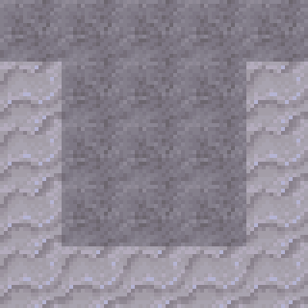 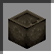

### Carbon Rod

The carbon rod is made using one piece of coal and a knife, in the crafting space. Any knife can be used.



### Copper Rod

The copper rod is made two ways, either using a ceramic mould or via an anvil plan.

To create the clay mould, use the follow knapping recipe. It then needs to be fired to make the ceramic rod mould.

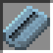

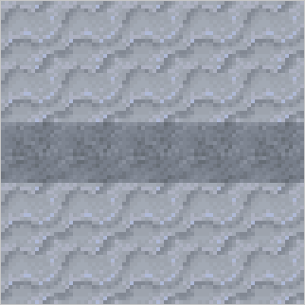

Using the ceramic mould, the player can heat copper ore using the small vessel and fill the mould.

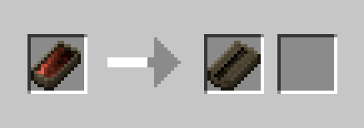

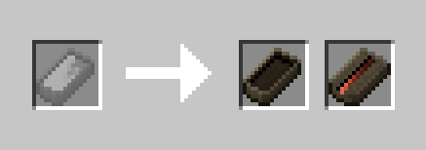

Then using the crafting space, the player can remove the copper rod from the ceramic mould. The ceramic mould is lost in the process.

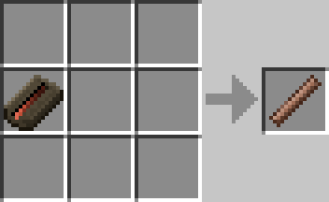

To create the copper rod using an anvil plan, place a workable ingot of copper in the anvil slot and click the plan button. Select the copper rod plan from the list.



The by using the anvil buttons, create the copper rod. You will get one copper rod per ingot.

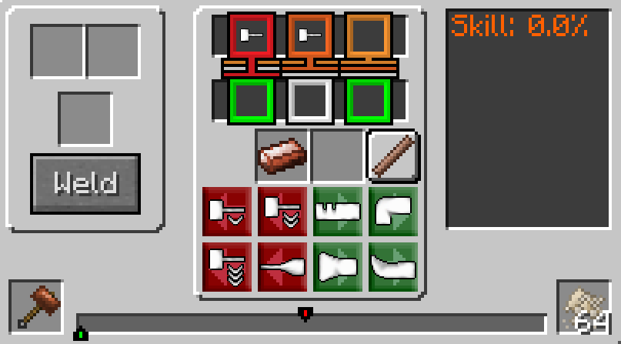

### Copper Wire

Copper wire can only be made using an anvil plan. Place a workable copper ingot into the anvil slot and click the plan button. Select the copper wire plan from the list.



Then by using the anvil buttons, create the copper wire. You will get 10 copper wires per ingot.

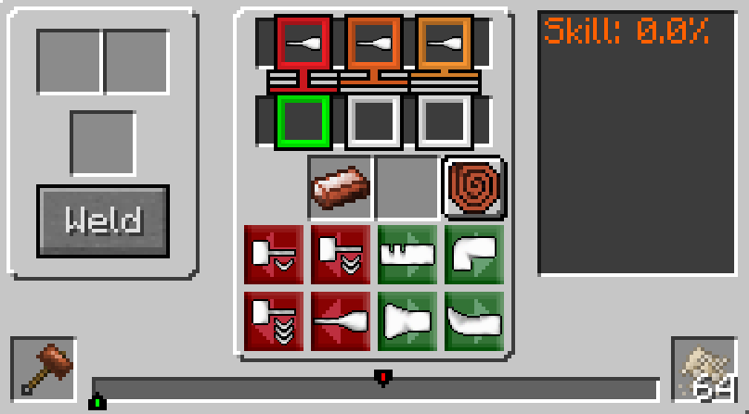

### Sulphuric Acid (Bottled)

Sulphuric acid is used in the construction of the battery and can be made in two ways. To make the acid the player requires - one bottled water and two sulphur powder.

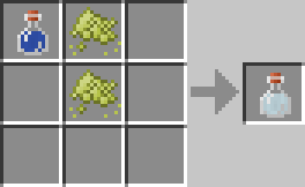

Or one bottled water and one gunpowder.

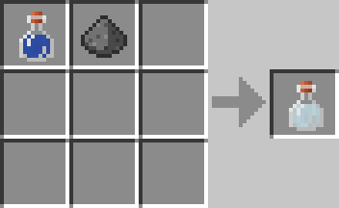

### Ceramic Battery

The ceramic battery is one of the four components used in the extraction process. To make the battery the player requires – one small ceramic vessel, one bottled sulphuric acid and two copper wires.

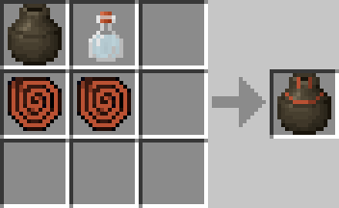

Recharging the battery can be done easily but adding more sulphuric acid to a ceramic battery.

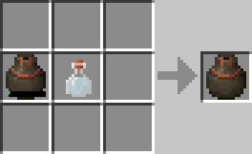

### Anodising Vessel

The anodising vessel is the container that houses the extraction process. To make the anodising vessel the player requires – one large ceramic vessel and two copper wires.

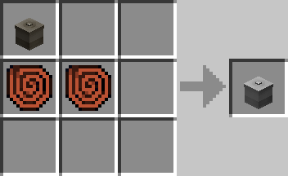

### Cooked Limonite

Before nickel can be extracted from the limonite, the ore must first be cooked using the ore cooker. Put the ore cooker over a forge and light the forge. As the temperature of the forge increases, so will the ore cooker.

To cook the limonite, drop the limonite ore into the top input slot. When the ore cooker is hot enough, it will start cooking the ore and the cooked limonite will appear in one of the two output slots. Any limonite ore can be used.

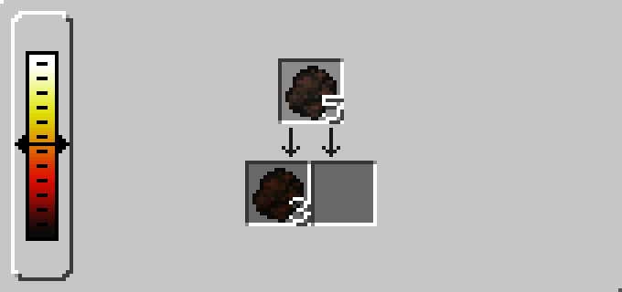

### Cooked Limonite Powder

Once the limonite ore has been cooked it then must be powdered. To powder the cooked limonite, open your crafting space and with a hammer, crush the cooked limonite.

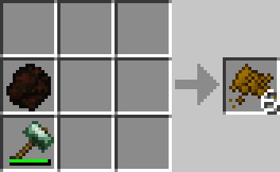

### Sulfuric Acid

Sulfuric acid is used as an alternate to vinegar in the extraction process. Using sulfuric acid over vinegar will yield better nickel results, but also damage your cathode and anode rods quicker. To make the acid the player requires –

Filling the anodising vessel with fresh water, a minimum of 200mB is required. Then place 1 sulfer powder per 200mB of freshwater into the slot. To make a full vessel of Sulfuric acid, 25 sulfer powders are required.

*Note: Only the anodising vessel can be used to create the acid.*

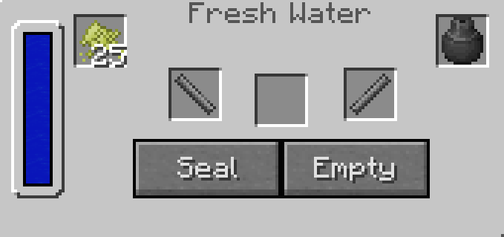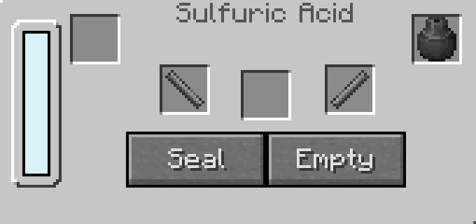

## Starting the Process

Before the process can be started the anodising vessel must be filled with an acid solution, either Vinegar or Sulfuric Acid. To fill the anodising vessel with vinegar, use a wooden bucket and transfer the liquid to the vessel, by right-clicking the vessel with the bucket of vinegar equipped. If the player wants to use Sulfuric acid, then use the recipe above, filling the anodising vessel with fresh water the same way they would with vinegar.

Note: The input slot cannot be used to fill the vessel with liquid.

The process is started by right-clicking the anodising vessel to open the GUI interface. Then the player drops the required items into the correct slots as shown below. The four required items are a Battery, Carbon rod, Copper rod and at least one Cooked Limonite powder.

Click the Seal button and if all the requirements are met, it should display ‘Processing’ at the bottom. If you see ‘Idle’ then the requirements were not met. Check that the battery has charge, and the copper rod is not fully damaged.

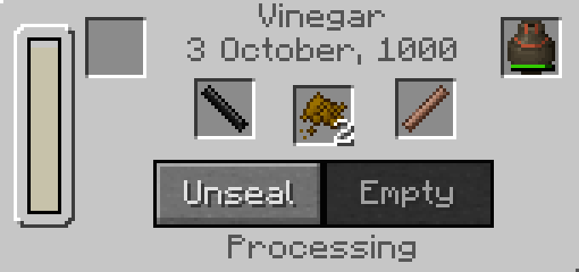

## Process Completed

At the end of the process, the copper rod will accumulate nickel and the image will change.

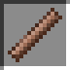

The player can see that the process is finished when all the Cooked Limonite powder has dissolved and ‘Idle’ is shown. As each piece of Cooked Limonite powder is dissolved and processed, the carbon rod and copper rod take damage. Also the battery charge is reduced.

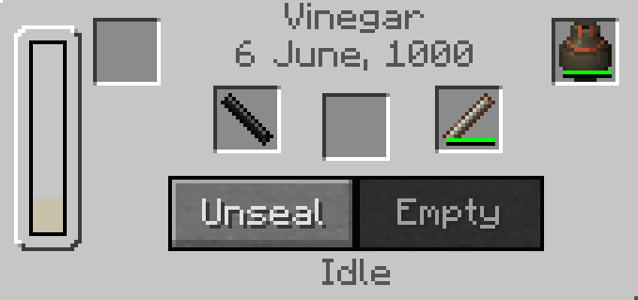

Click the Unseal button to unseal the vessel.

## Scraping the Nickel

Once the process is finished and the vessel is unsealed, the copper rod (nickel coated) can be removed from the vessel.



Put the copper rod in the crafting space with a knife to remove the nickel flakes. In the crafting window, it shows your copper rod, but the Nickel Flake will be added to the inventory. Any knife can be used.

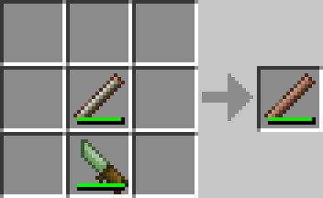

This is an image of the Nickel Flake. Nickel Flakes are 10 units and stack to 64. In the scraping process, if there is any excess nickel flake left over a smaller stack is created.

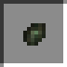

The Nickel Flake can now be melted down in a small vessel or using the crucible.